8th Lab – Stepper Motor Interfacing with AT89C51 Microcontroller
Implementation:
Keil:
Open Keil µVision → Go to Project → New µVision Project → Set a project name and save it → In the Select Device for Target window, search and select AT89C51 → Click OK → When prompted, click No → In Project window, right-click Source Group 1 under Target 1 → Select Add New Item to Group 'Source Group 1' → Create and save a new C file → Write the code below and save:
Source Code:
#include <reg51.h>
void Delay()
{
int i, j;
for(i=0;i<1000;i++)
{
for(j=0;j<100;j++)
{}
}
}
void main()
{
while(1)
{
P2=0x03;
Delay();
P2=0x06;
Delay();
P2=0x0C;
Delay();
P2=0x09;
Delay();
}
}
→ Right-click Source Group 1 → Add Existing Files to Group → Select the saved .c file → Click Add and Close → Right-click Target 1 → Options for Target → Go to Output tab → Check “Create Hex File” → Go to Target tab → Set Xtal (MHz) to 11.0592 → Click OK → Press F7 to build the project → If there are no errors or warnings, your code is okay.
Proteus:
Open Proteus → Click New Project → Set project name → Keep clicking Next until Finish → Click Finish → From the left sidebar, select Component Mode → Click P → Search and add AT89C51, ULN2003A, and Stepper Motor
Component Placement:
Place U1 (AT89C51) on the workspace → Place U2 (ULN2003A) beside it → Place Stepper Motor on the right side → Add two DC Power Sources (12V) from Generator Mode
Wiring:
• P2.0 → ULN2003A Pin 1B
• P2.1 → ULN2003A Pin 2B
• P2.2 → ULN2003A Pin 3B
• P2.3 → ULN2003A Pin 4B
• ULN2003A Pins 1C–4C → Stepper Motor Coils
• ULN2003A COM Pin (Pin 9) → +12V DC
• Stepper Motor Common Terminal → +12V DC
• All Grounds (MCU, ULN2003A, Power Supply) → Common
Programming:
Double-click U1 (AT89C51) → Set Clock Frequency = 11.0592 MHz → Browse and select the U1 HEX file generated from Keil → Click OK
Simulation:
Click the Play button → If the Stepper Motor rotates clockwise continuously, your setup is working correctly → Save the project.
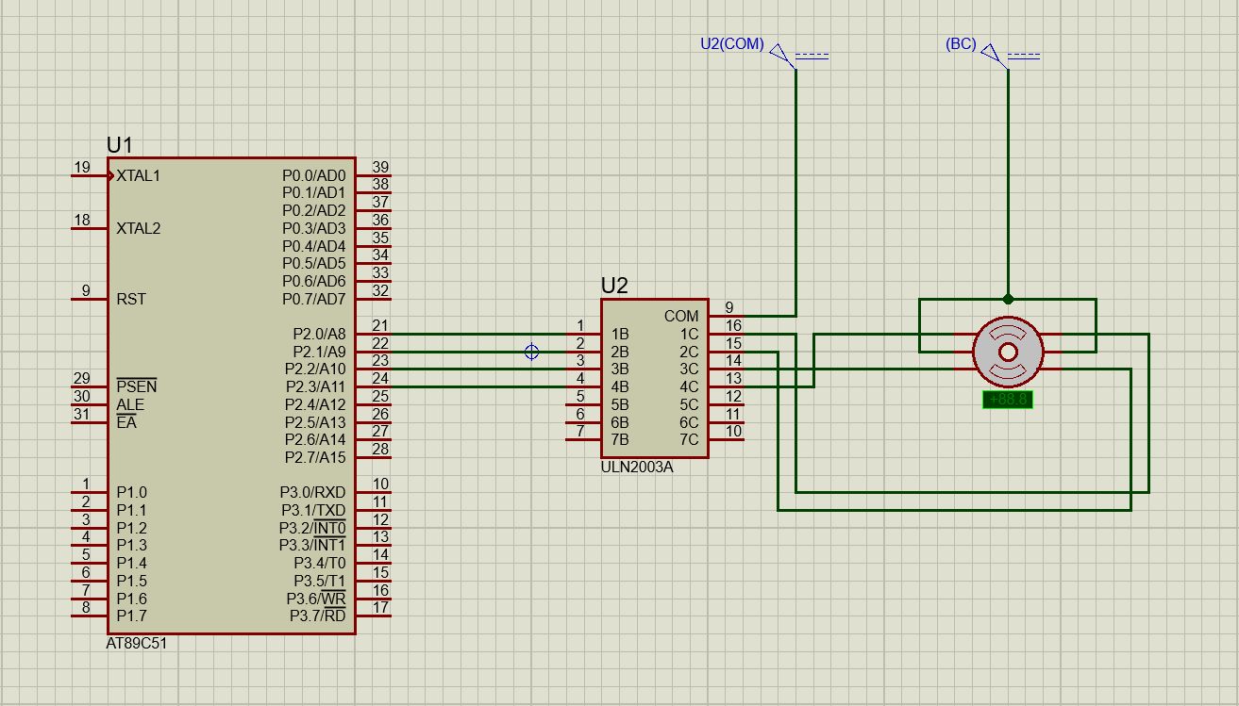
Diagram:

